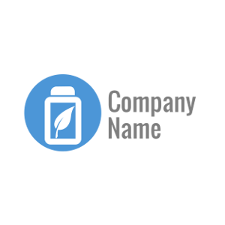Document No:

Incident No:

Customer Number:

Customer Name:

**DATABASE REQUEST**

**Good day,**

In response of the continous development of our system. We hereby requesting for a temporary maintenance and requesting for your information to be pull out for the enchancement and the additional entries of our database fields. Since the patch and improvement of the current system will affect the current tables where your information is placed, adding database field on every user information is a must and a protocol. The said patch will guaranteed safe and there is nothing to worry about.

Here is the concurrent information that we will be pulling out.

|  |  |  |  |  |  |
| --- | --- | --- | --- | --- | --- |
| **User Number** | **User Name** | **Full Name** | **Email Address** | **Age** | **Birthday** |
| 00000 | Sample | Sample Sample | sample@sample | 25 | April 8,1994 |

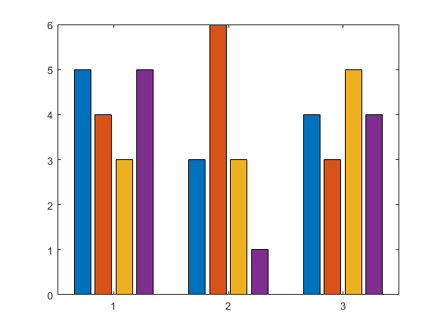**Here is your usage status:**

Session Time:

Usage Time:

Traffic Time:

Bounce Rate:

Channel Time:

Developer Notes:

____________________________________________________________________________________________________________________________________________________________________________________

____________________________________________________________________________________________________________________________________________________________________________________

Customer Feedback:

|  |  |  |
| --- | --- | --- |
| No. | Description | Reply |
|  |  |  |
|  |  |  |

Thanks,

Development Team